L02: Activity Reflection (Learning Journal)
After completing the activity, fill in the table below.
Instructions
- Choose two features from your website
(for example: navbar, grid, card, or any bootstrap feature).
- Copy 3–6 lines of code related to that feature.
- Write 1–2 sentences explaining what the code does.
Feature Used  Navbar / Grid / Card / any bootstrap feature | AI Prompt Used  Write the prompt you used | Code Generated by AI  Screenshot a small section of the code related to the feature | What I Modified  Describe what you changed | What This Code Does  Explain what the code does
Example:  Card | Generate a Bootstrap card with image, product name and price | 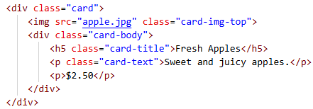 | Changed the product name, description and price | Displays a product card with an image, product description and price
Navbar | Help me make a nav bar that in every page at the top I can go to products, home page and contact us | 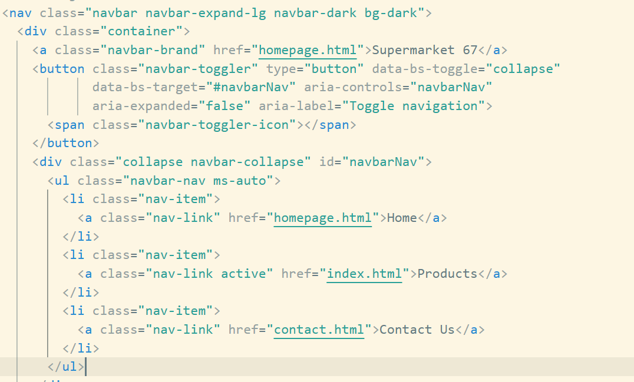 | Changed the brand text to “Supermarket 67.”  Marked the correct page link as active depending on which page I was editing (Home, Products, or Contact Us). | Creates a responsive Bootstrap navbar with links to Home, Products, and Contact Us. It stays at the top and adapts to different screen sizes.
Image Size Adjustment | How do I change the size of the image I inserted | 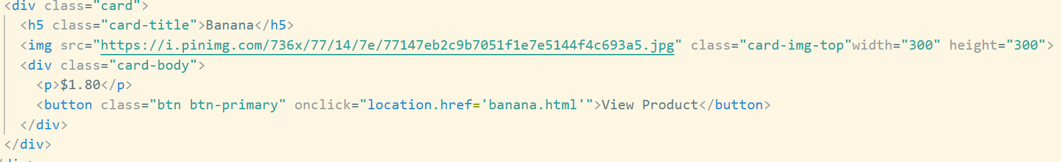 | Added specific width and height values to control the image size  Adjusted the numbers until the image displayed neatly inside the card | This code displays an image inside a Bootstrap card and resizes it using the width and height attributes. It ensures the product photo fits properly without stretching the card layout.

